Ventilator Project Circuit

Parts list

* LCD I2C 16x2 inbuilt display brightness adjustment
* Arduino Nano / Uno
* 30A monster shield board
* 3 push on/off buttons (JST Connectors for setting pushbutton in the casing)
* Encoder input Respiratory rate (Hall sensor to Interrupt or Phase AB encoder)
* Airspeed sensor or BMP 180 sensor
* Piezo buzzer

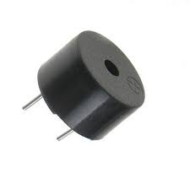

Basic Machine Connections

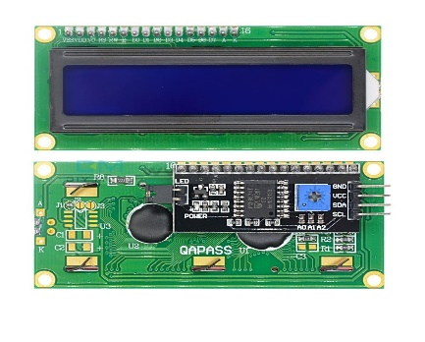Connections

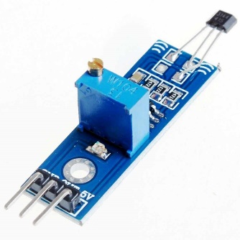

Buzzer

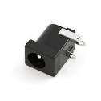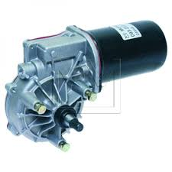 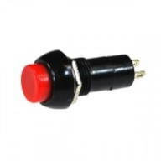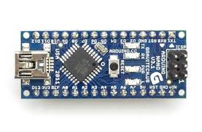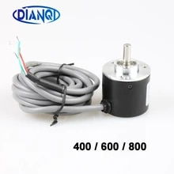

Power Supply 5V

JST 4 pin Connector to PCB

Respiratory rate increment

Respiratory rate decrement

Dual Motor Shield for redundant Motor control

I2C LCD

Interrupt pin 2,3

JST connector for easily connect either system

Start

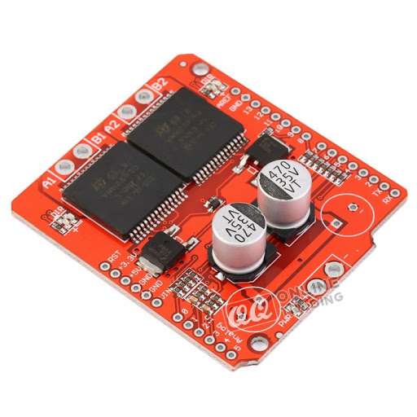

12V supply

Improvements

Airspeed Flow and Pressure measurement or BMP 180 based pressure measurements

* MPXV7002DP Differential Pressure on Analog A5/A4
* BMP 180 I2C Pressure sensor and temperature sensor I2c Connection

Note: Please Keep other extra pins connected to an JST 2.54 connector or pads where as we can use them for any other requirement situation easily without tracing wires over the cct which could arise on Covid epidemic situation.

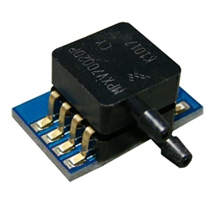

Analog Connection to A4 or A5

JST connector



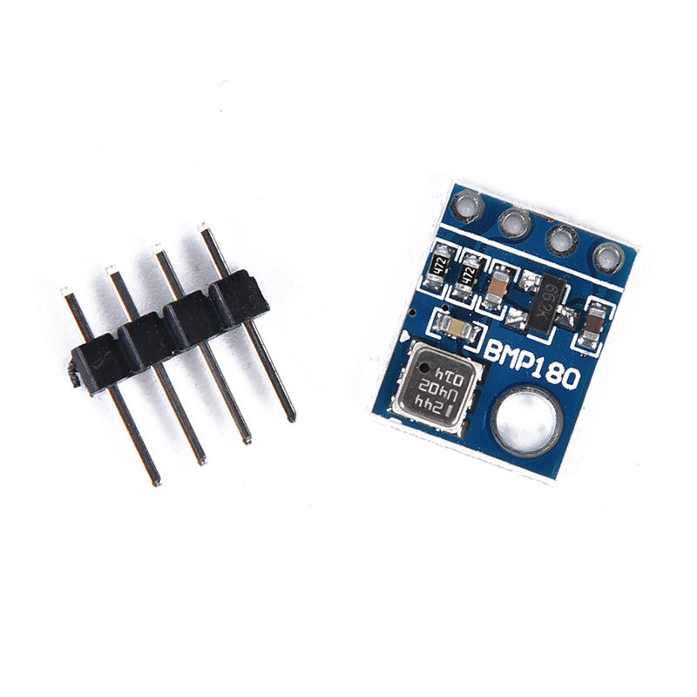

I2C connection

JST connector 4 pin (2.54)

* Humidity control and O2 concentrations system will be developed separately whereas

parts have to import, which is not locally available at this moment.